**`**



**ICENI MICROSCOPY**

**STUDY GROUP**

**Slide Making** September 2020

**Overview.** Mounts may be dry, fluid or in a solid mountant, temporary or permanent.

While some ‘smears’ will be the basis for a permanent slide, others will be temporary. Some temporary slides will not have a cover slip; others may need one to protect the microscope objective lens. Resin or jelly mounts are permanent and are considered to be archival.

Making good slides is a difficult art; once all the equipment needed has been assembled, it is best to make several, keep the best and discard the others.

The preparation of material for resin mounting (the more complicated) involves: killing, fixing, (perhaps staining), dehydrating, clearing and mounting. If there is a choice, a resin mountant is to be preferred because it will last. Many one-hundred-year-old slides are still as good as when they were made.

Before beginning, are all the tools needed to hand? Are they as sharp as possible? Check by examining them under a low power stereo. If not, use emery paper or an emery stone. Do your forceps meet neatly at their tips? Entomological pins mounted on cocktail sticks or glued to the tips of watchmakers’ forceps are useful tools.

Cleanliness is important. Do not work in a cluttered or dusty environment. Many operations cannot be carried out one after the other but require a pause between them, perhaps while something sets or dries, so have some dust guards ready; plastic milk bottle caps are perfect for this.

**Solvents and mountants.** Although xylene and toluene have been used extensively in microscopy procedures, both are organic solvents recognised as a danger to health (particularly toluene) by both skin absorption and vapour inhalation so wherever possible use other safer solvents. One is Histoclear, obtainable in different formulations from Brunel Microscopes and Agar Scientific. D-limonene seems to be the same thing, but much cheaper. This has been used in ‘clearing’ in the final stages of specimen treatment prior to mounting in our recommended resin mountant, Practamount (which comes in xylene); this is obtainable from Colin Kirk [colinkirk@tiscali.co.uk](mailto:colinkirk@tiscali.co.uk). Histoclear has also been successfully used for dissolving wax in the preparation of ‘sections’.

It has been said that subjects can go straight into Practamount as this is miscible with alcohol and remains transparent but, as water held in suspension in the alcohol may not all have been removed, this may be unwise; any water will turn the slide white and give it a white bloom. Going directly from alcohol to Practamount with stained specimens can lead to the colour ‘bleeding’; more work needs to be done on this.

Cellulose thinners have been used successfully to dilute Practamount. Caution is advised since these thinners may vary in composition and should first be tried, if hygroscopic they may cause blooming.

While subjects mounted in Canada balsam have lasted 100 years (and those in Practamount seem likely to do the same), neither is particularly easy to use and there are often small bubbles. After mounting, put the slide on a hotplate for 24 hours to allow bubbles to disperse.

Another replacement for Canada balsam is Gum Damar.

Several experienced slide makers recommend the mountant Euparol. They say it is easy to use and there are seldom any bubbles. Its durability, however, is not yet known. It is obtainable from Anglian Lepidopterist Supplies [www.angleps.com](http://www.angleps.com/).

**LOCA**. Although not yet fully tested, another good safe mountant seems to be LOCA (liquid optically clear adhesive); this is made for repairing smart-phone screens. Grades 1000 and 2500 are available, the latter being more viscous. A short length of 20mm plastic waste pipe makes a cheap plunger but it is better decanted into a small brown glass bottle and dispensed with a glass rod. UV light cures LOCA. UV torches are readily obtainable (often used to detect urine); one with a wavelength of 365nm would be best.

As with any mountant, added LOCA may include bubbles. These may be sucked out using a pipette tip mounted in a rubber pipette bulb.

LOCA is miscible with xylene, Histoclear (d-limonene) and cedarwood oil (often used for clearing), but not with alcohol or water. While cedarwood oil works well after the dehydration or clearing process, make sure there is only a small quantity left on the specimen.

Specimens can be processed in alcohol and then put on a hotplate @ 45°C for ½ to 1 hour; this drives off the alcohol when, happily, LOCA replaces it.

After curing with UV, LOCA sets to a very firm gel. Remove any oily residue with a household detergent such as “Cillet Bang Power Cleaner”. Excess LOCA around the coverslip is removed by dipping the slide into hot water and either scrubbing with a toothbrush or peeling it off with a fingernail. **See Annex B, method 3.** Stubborn excess may be removed with butyl or ethyl acetate.

Those wondering which mountant to use are referred to a Natural History Museum report of a [survey](http://www.nhm.ac.uk/hosted-sites/acarology/archive/summary.html) by R B Halliday in 1994.

**Cleaning.**

*This is important since imperfections and dirt will also be magnified and resolved!*

Slides and cover slips, particularly the disc ones, often come from the manufacturer with dust, grease and small glass shards so need washing before use. Three ways are:

1. Scrub with an old toothbrush dipped first into a standard cleaning fluid (50:50 methylated spirits: water with a small dash of washing-up liquid), then with scouring powder or ‘Jif’. Finish by wiping with a soft cloth (clean old handkerchief) until dry and free of abrasive, polish with chamois leather and put back into their vacuumed box ready for use, or:

2. Use a 2-5% solution of ‘Decon 90’, a surface-active cleaning agent. Keep some ready diluted in an old plastic milk container - immerse your glassware, leave for 24 hours then rinse in demineralised water, dry and polish. Cleaning time can be reduced by heating the solution to 40-50°C. To ensure the removal of all traces of contamination and the cleaning agent, the manufacturer recommends three agitated rinses in water. As it is alkaline, it should not be used on non-ferrous metals, such as aluminium or zinc, or on polycarbonate.

3. Used glassware (pipettes, bottles) may be cleaned using a 2-5% solution of Decon 90, followed with rinses first in demineralised water then acetone (more correctly known as propanone).

N.B. The much cheaper Cillitt Bang degreaser seems to work as well as Decon 90.

**Glass slides.** Different companies and manufacturers offer a range of slides of differing quality but, for most microscopy work, the cheaper ones are good enough.

**Cover slip thickness.** Most high power objectives are designed for a cover slip thickness of 0.17 mm. Use of a cover slip of the wrong thickness on a high powered microscope may distort your resolution. Use only #0 or #1 on high power microscopes; this is essential for

|  |  |
| --- | --- |
| **Coverslip number** | **Coverslip thickness (mm)** |
| #0 | 0.08 - 0.12 |
| #1 | 0.13 - 0.16 |
| #1.5 | 0.16 - 0.19 |
| #2 | 0.17 - 0.25 |

x500 and above. While exact sizes vary with manufacturer, the #1.5 and #2 are suitable for up to x400 because the objects examined at this size are small, e.g., pollen and Nosema spores, and these naturally fall onto the top of the slide. A thick cover slip makes a robust slide; those made with the thinnest are very fragile. Often a few per cent of cover slips in a box are outside the supposed range. Also, when the sample is on the slide, there may be a relatively thick layer of mountant between the sample and the cover slip - so for high power work standardisation on #1 is recommended. Too thick a layer of mountant may be reduced by putting a steel nut or an old AA battery (right diameter and heavy enough) on the cover glass while it sets/cures.

**Cover slips** Suppliers offer them in various diameters from 9 to 19 mm or, more cheaply, square or oblong. For appearance, disc cover slips ‘fit’ the view through the microscope so often look better. Discs may be cut from squares using a glass cutter or, better, a diamond pen. Ideally, the size of the subject should be matched to the size of the cover slip; pollen grains are small and are viewed at a high magnification with a small field of view, so small cover slips are best for them.

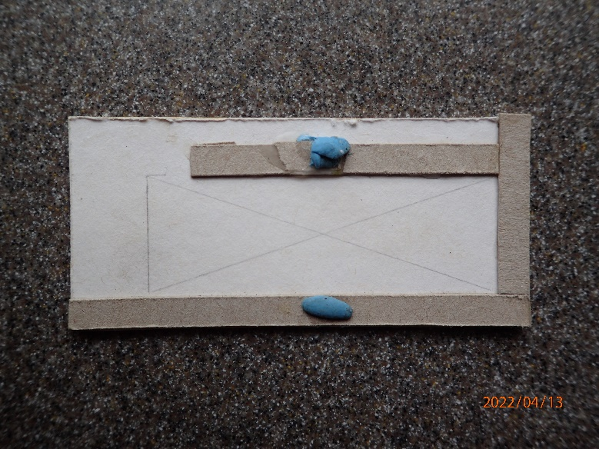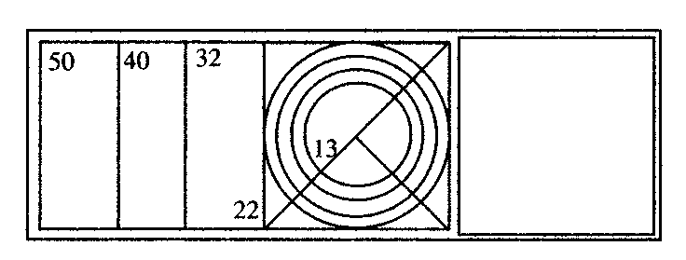

**TOP**

**Ensure the specimen is central and upright.** The best slide makers ensure their specimen is precisely in the centre of their slide and upright. One way is to use a mounting guide (see below). Another is to follow Peter Sunderland and, as the final part of preparing slides, use a ringing table and a fine ‘permanent’ marker to draw on the back of each one, two small central circles of, say 13 and 16 mm diameter, around a dot at the slide centre. To avoid mounting the specimen on top of these marks, use the same pen to mark the upper side ‘TOP’. In the final clean-up after mounting, these marks go.

Or use a fine marker and the edge of another slide to add 3 vertical lines and a single circle around the centre.

**Allowing for Thicker Specimens.** Pollen grains are small, less than the thickness of the layer of mountant. Other thicker subjects, such as insect body parts, must often first be compressed to reduce their thickness before mounting - but pressing them too much distorts them. To allow their detail to be seen, dark specimens may also need bleaching; this can be done using 20% household bleach. Check progress every 20 minutes. Over bleaching may make the specimen invisible when mounted.

Cavity slides provide depth and have the added benefit that anything small will naturally sink to the centre of the cavity - but they are expensive and not very deep. More depth can be provided with a spacer such as a ring of aluminium or brass; match ring and cover slip diameter. Another way is a ring of gold size, or the resin mountant of your choice, built up layer by layer.

More commonly, spacers are used - a trio of tiny slips of paper or plastic. Almost any material may be used - small pieces of flat plastic, short lengths of monofilament fishing line, etc. Especially when making resin mounts, spacers and specimen are usually arranged in a thin layer of mountant at the same time; after an hour or so in a warm place, when these items can no longer "drift", more mountant is added and a cover-slip put in place. Spacers are often better than a ring because the gaps between them allow excess mountant to escape.

If you intend to glue your spacers in place, first check that your glue dries clear; Pritt stick and Pritt glue are good; some PVAs dry white. If card (½ mm thick) is used, cut it with a scalpel and stick three spacers in place @ 120° to each other using, say, PVA glue thinned 50:50 with water. Manipulate the supports into place with fine forceps. Only 1 mm of the support needs to be under the glass. After sticking, allow it to dry for an hour then seal the card upper surfaces with the same glue using a small brush; a failure to seal may allow air to be drawn through the card to form bubbles as the mountant cures.

**Before you begin.** If intending to use a resin mountant (Canada balsam or a substitute such as Practamount or Numount), subjects preserved in vinegar or FAA (formalin acid alcohol) must first be thoroughly dehydrated. If the specimen is robust enough, agitate for at least a minute in three changes of propanol, first 70%, then 95% followed by two changes of absolute before going into xylene (or Histoclear). Going into absolute too quickly may distort the tissue. With delicate or friable tissue, start with 50 or even 30% and consider an intermediate 80%. Operations may be carried out at 24-hour intervals, once a day; none will be spoilt by leaving them longer between manipulations.

**Pressing subjects before mounting**.

Subjects which are the wrong shape to fit conveniently on a slide will need pressing before mounting. Cut an ordinary glass slide into 3 and put your subject between two of them; they may be held together with a paperclip or by winding some cotton thread around them. With a spacer in the corners of each square, these may be used in three ways: with spacers together, or, if the specimen is not compressed enough, one side can then be put plane to spacer, which will give half the difference. Or the sandwich can be made with spacers to the outside, glass to glass, when there will be no clearance. Only compress just enough to achieve the pose wanted. Once the alcohol has taken effect, the subject will be fixed and will not change shape if put into xylene (or Histoclear).

Slide makers try to display the subject as well as they can. It is dispiriting carefully to arrange it, add the mountant and the coverslip only to see the subject float off to one side. To prevent this, first stick it in place. Ways of doing this are:

* Apply a thin layer of mountant where the subject is to go. It is then carefully arranged until the underlying mountant dries and holds it in place.
* Apply Superglue to the subject, e.g., an ant, and then add it to the slide.
* PVA glues may be thinned 50:50 with water.

‘Pritt Stick’ is unsuccessful and fails after about 12 months.

**Mounting.** Once dry, the mountant and a coverslip may then safely be added. It helps to avoid air bubbles if, before lowering the coverslip, it is first ‘lubricated’ by dipping into xylene or toluene for resin (or water with a drop of alcohol for glycerine jelly) but be careful to shake off any excess.

For the best result, carefully manipulate the subject into a suitable pose. This may take 40 minutes! When starting to manipulate a fixed specimen, (which may be in alcohol or xylene), begin by adding extra solvent for a 50:50 mix. This is essential for setting the subject. For wings, even more alcohol or xylene is needed to float them into position. When the pose is set, put the slide onto a hot plate; the excess alcohol or xylene will be driven off and it will glue the subject in place ready for the next stage a day later i.e., leave it on the hotplate for 24 hours before the next layer of Practamount. If, too thick a layer of Practamount is added, the sub-base may dissolve and the subject move. The secret is to add a very, very small amount, ½ a drop of mountant every 24 hours. Do not be tempted to wet the surface with solvent to get a better key.

When the subject is well locked up and the base Practamount is in a hard crystal state, test it with a pin. If it flakes off like ice, add the cover-slip. Give it 24 hours to harden, check it and give it a further 24 hours, maybe even more, because the volatiles can only evaporate from the edge of the mountant under the glass cover-slip. At this stage, keep it hot - it will not be cooked.

**Slide Warming Plate**. Some heat is usually needed either to liquefy glycerine jelly or to cure resin mountants. While warming plates can be [bought](http://www.mindsetsonline.co.uk/Catalogue/ProductDetail/sep-mini-hotplate?productID=dfac027a-0dbf-42f0-8a31-31d23332fe4e&catalogueLevelItemID=899b5243-a61c-4d26-8224-328cc73df4cb), it is not difficult to make your own - see page 9. If using glycerine jelly, warming it to 40°C is enough (a maximum of 50°C) or it may crack when it cools or break down into metagelatin, a liquid that will not set.

**Bubbles.** These are the bane of a slide maker’s life and too often spoil hours of work. They may be caused by:

a. Slides not immaculately clean.

b. A subject drying out so leaving a cavity - never, ever, let this happen. In the course of preparation, immerse the subject in the appropriate solvent (xylene, Histoclear or alcohol) and keep it wet.

c. Stirring the mountant.

d. Adding mountant. To avoid bubbles, first dip your glass rod into the appropriate solvent, then pick up some mountant and let it drop naturally onto the slide.

e. Adding cover slips; first dip them into solvent before lowering them onto the slide; wet glass generates no bubbles.

f. Some plant life if not killed correctly and then in a liquid mount will produce oxygen by photosynthesis under the cover glass.

If bubbles appear, do not jettison the slide. If not too long after placement, cover slips can be removed, dipped into solvent for cleaning and re-use. With an old slide, submerge it in xylene / Histoclear until it comes apart. Re-assemble. Consider why there were bubbles.

**Ringing.** With glycerine jelly, once the specimen is covered, the edge of the cover slip must be sealed within a day or two (see Annex B below) to prevent atmospheric moisture seeping in and damaging the work. Sealing square or oblong cover slips is also called “ringing”.

**Ringing table.** To apply sealant to a circular cover slip, a ringing table is needed. This is a small book sized device which carries a free spinning disc; the disc is fitted with two light clips to hold a slide and a support for the brush hand. Try before you buy because some on the market do not spin as freely as they ought.

**Brushes.** Cheap paint brushes have parallel bristles. In good ones made with animal hairs such as sable, squirrel or pig, bristles taper towards the tip. Brushes should be cylindrical. Size varies with make but #2 is about right. It is a mistake to use too small a brush.

Rosemary & Co. Ltd. offer good brushes, a Red Sable Blend is recommended with a round pointed end. Suitable brush sizes are catalogue no. 401SH/2-0 for the application of black and 401SH/3-0 for colours. See: [rosemary@rosemaryandco.com](mailto:rosemary@rosemaryandco.com); 01535 600090; web site [www.rosemaryandco.com](http://www.rosemaryandco.com/).

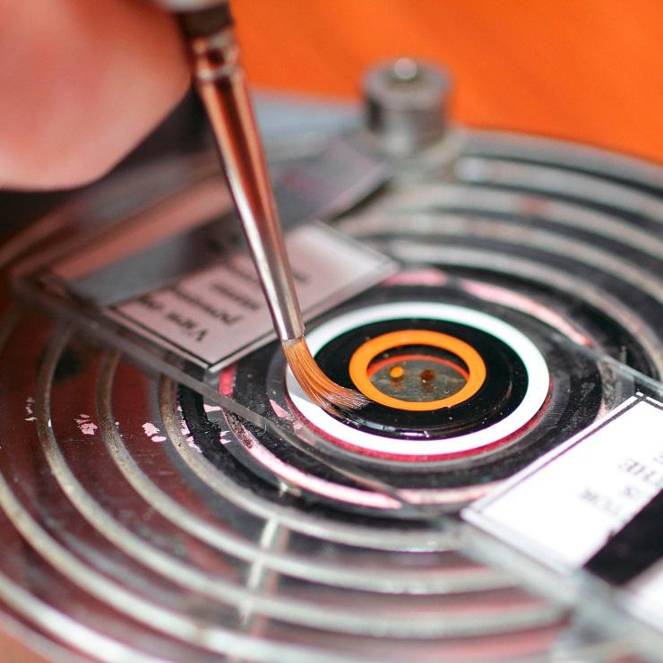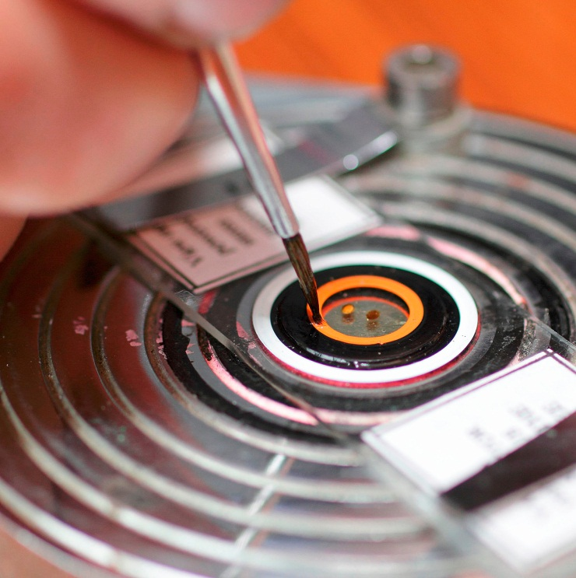

For a right hander

Diagram 2

Diagram 1

For a right hander

Gold size is a good initial sealant since it acts as a barrier, preventing any reaction between the mountant and whatever decorative finish may be applied later. Other choices for initial sealants are French polish, carpenters’ knotting and nail varnish. Resin mountants need no initial sealant but may take 6 weeks or more to dry; their drying can be hastened if they are first put onto a hot plate at 50°C for a couple of days.

[When slides are clean and dry, decorative rings of enamel paint may be applied. Small pots of Humbrol enamel are available from hardware, toy and model shops or](http://www.rosemaryandco.com/) [www.humbrol.com](http://www.humbrol.com/) for c.£2.00 a pot. As soon as a pot of paint is opened, it begins to lose its volatile dryers and so its consistency will change; it will thicken and start to form a skin. In other words, it does not keep. Since these small pots cost so little, it is better to buy another than continue too long with an old one. Craftsmen reduce the air volume, and so minimise the loss of volatile constituents, by replacing the paint used with ball bearings or small washed pebbles.

Peter Sunderland of the Iceni Microscopy Study Group recommends using cellulose thinners with Humbrol, not theirs, and different brushes and jars of thinner kept carefully only for that colour. Make a block with cut-outs so that each paint is kept next to its jar of thinner. Just before use, stir the paint with a match or a cocktail stick.

With a cocktail stick, the dirty end may be broken off after use and discarded so reducing the risk of cross contamination. In other circumstances, cocktail sticks may be better than glass rods because some things stick to glass.

Put the slide onto the ringing table, ensure it is central and secure it with the clips. To check the slide is placed correctly, spin (anticlockwise for right handed people); if not, adjust. Begin by priming the area to be painted; priming ensures the paint does not spread further than is wanted. Load the brush with thinner and, holding it almost vertically but with the top slightly inclined away (to the right for right handed people), apply it with just a little pressure onto the right hand side of the spinning cover-slip; **the idea is that the liquid should be drawn smoothly from the tips of the brush bristles** - so barely half the length of the bristles should be in contact with the glass, just enough to define the edges neatly.

It is suggested that as a base paint, a black ring should be applied first. Load the brush by dipping it again into solvent and then the **tips only of the bristles** into paint. Apply a ring as above, approximately 4 to 5 mm wide, the smaller measurement for small cover slips, wider for larger. Contra-intuitively, the thinner the paint, the better it will adhere to the glass. Apply the first ring with confidence and enough pressure to form a neat ring with precise edges. When established, any more paint added will not bleed outside the ring; second and third coats may be added immediately. When the table is spinning, hardly any pressure is needed to pull the paint off it into a high build. The longer the brush is kept in contact, the more paint will be pulled off the brush. Diagrams 1 & 2 (showing a finished slide) demonstrate how the brush should be held. The appearance can be enhanced by putting on, say, three coats one after another in one go, and then letting them dry. Twenty-four hours drying time must be allowed before adding any more paint for a final finish or the surface will crinkle and spoil. When dry, the paint should have a convex upper surface. First coats should always be slightly thinned to help them stick to the paint already there. The paint should be applied so that it finally attains the same depth as the coverslip, i.e., the edge of the coverslip should not be visible. To give the paint a really good gloss, a final well thinned layer may be added.

Additional rings can be added later - even months later if you wish. While there is no particular convention, some like to ring with a colour to indicate the slide’s contents, e.g., green: plant origin, red: body parts and orange: disease.

**Before** final ringing, **very carefully** re-clean as for a new slide.

Finally, the slide should be labelled. See the next page (7).

Slides should be stored horizontal, not on edge. For those on edge, the contents of glycerine jelly mountant slides tends to gravitate downwards, even when sealed. Be very cautious with resin slides as they may take months to dry.

*JDQ - grateful thanks for advice from PS, DG and LW*

Further reading:

*Practical Microscopy* by J Eric Marson available from Brunel Microscopes.

*Biological Microtechnique*, by J B Sanderson; Microscopy Handbooks No. 28 published by the Royal Microscopical Society.

*Practical Section Cutting & Staining* by E.C. Clayden available second-hand from Abe Books.

**Annex A - Slide Labels.**

Diagram 1

What is deemed important will vary from specimen to specimen but * indicates information that should always be included.

.

* **Specimen name**

* **Specimen description**, e.g. Section (Transverse section, T.S.; Longitudinal section, L.S. + thickness), Whole mount, Crystals, - - - .

Location of collection

* **Date**

Mountant

Stain(s) used

Name of preparer

Computers allow small clear lettering to be printed so are ideal for labels. Water based inks may 'run' during cleaning-up processes. Some waterproof their inkjet labels with the lacquer used to coat polished brass or even hairspray!

The late Mr T.C.D. Moore produced an Excel program that may be freely copied; this allows a single label to be printed if that is all that is required. It is available from the Iceni Microscopy Study Group.

**Gums for labels.**

1. A simple practical way is to use PVA wood glue, mixed 50:50 with water. This is painted onto the slide and, after a short period of time, the label is lowered on using tweezers. After a further short period, a matter of seconds, the paper bites onto the glue - then very carefully go around the perimeter with a damp paint brush to remove any excess.

2. The traditional recipe is:

|  |  |  |  |
| --- | --- | --- | --- |
| **Process** | **Ingredient** | **Full Quantity** | **1/20th of quantity** |
| Solution 1. | Gum Tragacanth | 30 g | 1.5 g |
| Water | 250 ml | 12.5 ml |
| Stand for some hours. Shake until the liquid froths and then mix with: | | | |
| Solution 2. | Gum Arabic | 120 g | 6 g |
| Water | 250 ml | 12.5 ml |
| Strain the mixture through linen and add to: | | | |
| Mixture 3. | Glycerine | 150 g | 7.5 g |
| Oil of cloves | 2.5 g | 0.125 g |

Notes:

1. This looks complicated, but the resulting paste is good; it is quite easy to make up.

2. I made up a suitable amount for my use by dividing each of the quantities quoted above by 20. A small digital balance can be used to weigh small quantities – these are obtainable for less than £20.

3. In mixture 3, there are plenty of alternatives to oil of cloves. In *"On Mounting Microscopic Objects",* Davis writes that we need "a small quantity of an essential oil [to prevent the growth of mould]. One fourth of its [the solution's] volume of alcohol would serve the same purpose".

4. The gums required can be obtained from a retailer of artists' materials and the essential oil from a high street pharmacy.

5. While some might decide that it is better to purchase a proprietary paper paste, I suspect that others like me will find the use of a traditional - and proven - recipe an attractive proposition. My original batch of this glue has not yet "run out", after several years, so I recommend making up a relatively small quantity.

LW., Nov. 2008

**Annex B - Mounting pollens**

Reference:*Pollen: Its Collection & Preparation for the Microscope* By J White, 1989.

Keep cover slips, slides, glass rods and jellies on the hotplate until needed. Make sure this is not too hot: 40 to 50°C max. [It is too easy to heat it too much. Surprisingly, White recommends 80°C.] After mounting, leave the slide on the hotplate for c.10 minutes - to allow the subject to settle and stabilise on the slide surface. Then, keeping it level, gently remove the slide and put into a fridge for 10 minutes. Clean by cutting very gently around the edge of the cover slip with a scalpel blade held vertically; carefully wipe away the surplus with a damp tissue wrapped around the end of a match. Ring in the usual way. Slides made this way give a better image through the microscope because the subjects will be on the slide surface, rather than being dispersed throughout the glycerine (100 -130µm thick), and there will be no need to rack up and down to find them.

**Method 1:** (**White’s - using unstained glycerine jelly)**

1. Put pollen onto the watch glass.
2. Add absolute alcohol (100% IPA) to k ill and fix. This also removes the ‘pollenkitt’ (outer oily coating).
3. Stain with either Safranin or Basic Fuschin; time & quantity dictate the degree of staining.
4. Rinse (and dehydrate) using more alcohol. When stained enough, use a pipette to remove IPA to a waste bottle.
5. Repeat until sure fully cleaned and adequately stained.
6. Swirl the watch glass to concentrate the pollen grains in its centre.
7. Add a drop of 50% melted glycerine jelly and mix to wet the pollen. (Some pollen grains may be desiccated and so collapsed; wetting restores their shape.)
8. Put a small drop of glycerine jelly into the centre of the watch glass.
9. Use the 50% jelly rod to move the pollen & jelly mix from the watch glass to the slide. Experience will tell you how much.
10. ‘Lubricate’ cover-slip in water (with a tiny drop of IPA) and lower gently into place: the melted jelly spreads to fill the area - if you have the right quantity!
11. Label.
12. Put the slide back onto the hotplate for 10 minutes to allow the pollens to sink to the upper surface of the slide.
13. Put slide into the fridge to harden.
14. When the glycerine is firm, clean carefully.
15. ‘Ring’ to keep air moisture from the jelly.

**Method 2 (Using ready stained glycerine jelly):**

Equipment: Hotplate

Thermometer to check temperature

Watch glass

Mounting guide card

Microslide

Coverslip

2 pairs very fine sharp forceps

Glycerine 50% (with water)

Dipper rod for 50% glycerine

Stained glycerine jelly & rod

Isopropanol & pipette

Waste bottle (say 250 ml)

Another pipette for putting pollen onto the watch glass.

Ringing liquid (e.g. nail varnish)

Label

Use the instructions for Method 1 but, with ready stained jelly, lines 3-5 are combined so there is no need for more stain. It may take a few days for the stain to transfer to the subject.

Method 2 is more suitable for beginners or in schools as the stains in Method 1 can be toxic and may stain fingers and clothes. Ready stained glycerine jelly is often used for pollen.

For both methods, a very small crystal of thymol, or a drop of clove oil, will kill any fungi and so prevent subjects degrading. It is, however, quite unusual for a subject to degrade because it will already have been fixed.

**Method 3 (Using glycerine jelly - but more successfully!)**

It has been found that adding the pollens to the glycerine jelly is more successful than adding the jelly to the pollens.

The pollens to be mounted are stored in IPA. Warm the glycerine jelly to c.45°C. With stained jelly, the particular stain used (fuchsin or safranin) will make a difference to the exact temperature required.

Add a drop of jelly to a warm slide. The size of the drop is important as, when the cover slip is added, the jelly should just cover the area below the coverslip. It is suggested a glass rod be marked to show how far it needs to be dipped to collect the right amount of jelly.

There will usually be a few small bubbles in the jelly. These should be removed before continuing. One way is to sweep them to one side and out using an acupuncture needle with a tip bent into a circle.

With a second clean glass rod, collect some pollen. As it is withdrawn from the IPA, much will evaporate. Touch the rod onto the jelly and, if necessary, repeat. The pollens will disperse throughout the jelly fairly evenly.

Add a warm coverslip.

When the glycerine jelly has filled the void below the coverslip, remove it from the heat to cool.

Ring and label the slide.

**Method 4** **(Using LOCA)**

Since no water is involved, pollen grains may be desiccated – and so collapsed.

Equipment: Hotplate

Microslide

Coverslip

Fuchsin

Clean slide and coverslip.

With pollen in alcohol (e.g., in an Eppendorf tube), add Fuchsin.

Drop of stained pollen onto slide centre. Allow to dry.

Add drop of abs IPA. Wipe carefully around edges. Allow to dry.

2 drops of LOCA. Check for bubbles (LOCA may entrap some).

Put onto hotplate @ 60°C for 1 - 2 minutes.

Add coverslip and press down gently (better, use an old AA battery).

Shine UV torch for c.3 minutes. LOCA sets with film of oil on top.

Use “Cillet Bang” degreaser, neat washing up liquid or kitchen cleaner to remove the oil. Wash under a hot tap.

Peel away the excess outside the coverslip.

Ring for appearance.

Label.

**Using LOCA to mount small insects or insect parts**

Equipment:

Hotplate

Micro slide

Coverslip

LOCA

Pipette tip mounted in rubber bulb

Mounted needle

Forceps

Light slide clamp (or clothes peg)

Prepare specimen.

Clean slide and coverslip.

Put subject onto slide. Degrease with drop of alcohol.

Position using mounted needle.

Add good blob LOCA to ensure specimen encased.

Using mounted pipette tip, suck out any bubbles.

Put onto hotplate @ 45°C for ½ to 1 hour to drive off any remaining alcohol. LOCA can be left on a hotplate in the dark for many hours without it setting so timing is not critical.

Scrape away any excess LOCA.

Re-arrange as necessary.

UV for 15 – 20 secs

Add more LOCA. The join will be invisible.

Using forceps, add coverslip.

Lightly clamp

UV for 30 – 60 secs.

Clean slide by putting into hand hot water @ 50°C and removing excess mountant.

Label

**Annex C - Mounting small insects and insect parts**

**1. Kill**. A one-pound honey jar with about 15 mm of plaster of Paris in the base makes a good killing jar. Mix the plaster with water - it gets quite hot while setting. Once it has set and cooled, add the killing fluid - ethyl acetate for preference. ‘Acetone free nail varnish remover’ is principally this.

**2. Preserve**. Once the subject is dead, move it to a preservative. Clear vinegar is recommended (alcohol makes them brittle). Another good option, especially for plants, is formalin acid alcohol (FAA); this also keeps subjects soft indefinitely and allows their later manipulation.

Subjects put into resin via alcohols, xylene, etc., don’t need any further preservative as they are in a medium devoid of oxygen or moisture and so unlikely to degrade. Again, don’t leave them in alcohol for long or they will become brittle. [If using glycerine jelly, it would be wise to counter fungi and/or bacteria by adding a few phenol crystals or phenol formaldehyde; 2-5% is enough. For plants, use thymol.]

**3. Prepare**.

1. So that a microscope can be used to examine them, subjects are often compressed between two pieces of glass. See page 4 above.
2. So that their detail may be seen, it is often necessary to treat them with 20% household bleach; this reduces their natural pigmentation and allows light to shine through them.
3. Check that your spacer is deep enough using a dry coverslip; if it isn’t, add more.
4. When ready to display, ‘arrange’ your subject on one third of a microscope slide. Be careful not to allow the subject to dry out or bubbles will be introduced.

4. **Dehydrate.** Add second 1/3 slide and clip them together. Dehydrate the clipped pair by agitating them for at least a minute in three changes of propanol, first 70%, then 95% followed by two changes of absolute before going into xylene (or Histoclear). Going into absolute alcohol too quickly may distort the tissue. With delicate or friable tissue, start with 50 or even 30% and consider an intermediate 80%. Operations can be carried out at 24-hour intervals, once a day; none will be spoilt by leaving them longer between manipulations.

Once the alcohol has taken effect, the subject will be fixed and will not change shape if put into xylene (or Histoclear).

**5**. **Mount**. Using xylene (or Histoclear) carefully float your subject off its 1/3 slide and onto its microscope slide. Position it centrally. While still keeping it just wet, allow the solvent to evaporate. Add ½ a drop of mountant. Move onto hotplate and cover against dust.

**6**. 24 hours later, add another ½ drop of mountant, re-cover and continue to warm.

**7**. Repeat until the volume within the spacer is almost full.

**8**. 24 hours later, add a final drop of mountant and the cover-slip.

**9**. Label.

**10**. Continue to warm for c.6 weeks until the mountant is thoroughly cured.

**11**. Carefully clean the slide and ring. For resin mountants, ringing is decorative, not essential.

**12.** Re-label.

**Making a Smear**

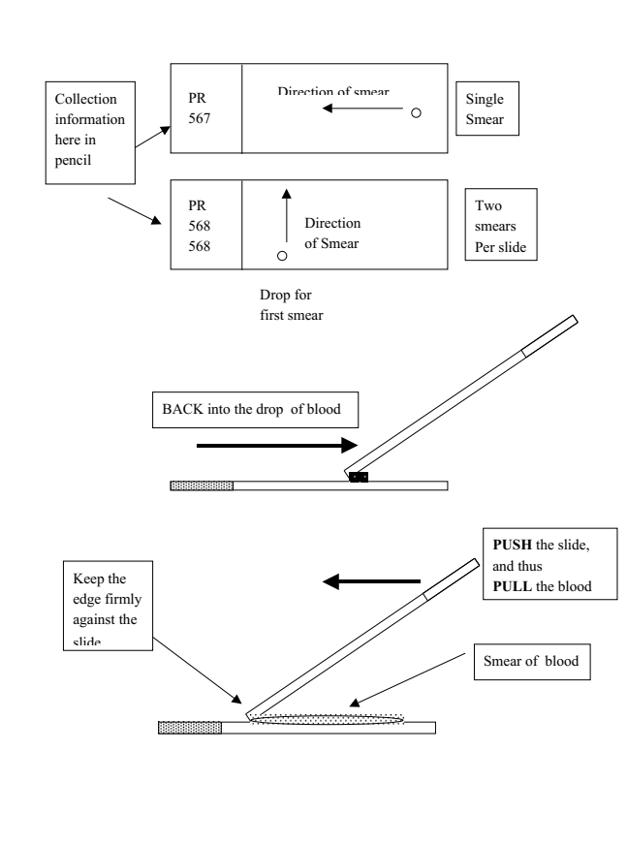From: <http://www.uvm.edu/~jschall/pdfs/techniques/bloodsmears.pdf>. This method is suitable for smears of other preparations such as Nosema, etc., etc..

Put your drop carefully onto the slide towards one end.

Spread the drop by using another slide (called here the “spreader”), placing the spreader at a 45° angle and BACK into the drop. The spreader catches the drop and it spreads by capillary action along its edge.

To make a short smear, hold the spreader at a steeper angle, and to make a longer smear, hold it closer to the drop. Now, push the spreader across the slide; this PULLS the drop across to make the smear. Do not push the drop by having it ahead of the smearing slide! It should take about one second to smear the drop. A smooth action is required, with the edge of the spreader held against the slide. This will yield a nice, even smear.

**Annex D - Slide Maker’s Warming Box** This is based on John Hunt’s suggestion.

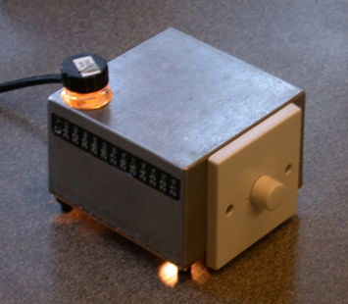

Even when the controller is turned down to its minimum, the 25w lamp will keep the glycerine jelly liquid, i.e. the temperature is above 35°C. The aquarium thermometer pictured does not extend high enough.

Alternative sources of supply: Rapid Electronics, Easy Control Gear or RS.

The box comes with a lid; discard this but keep the securing screws for holding the ply base cover in place. The base of the box becomes the top of the warming plate. A hole is cut in the far left corner for a small jar of glycerine jelly; this jar is supported on a small aluminium right-angled bracket; its securing screw also serves as an anchorage point for the earth wire.

Other holes are cut:

1. Centrally in the front for the controller – the top edge of the controller should be level with the top of the box. The lower side will be below the box bottom edge but the box feet will raise the box enough for this to clear the table.

2. In the back bottom left hand corner for the input socket (when looking at it from the back).

I fixed the lamp holder to the right hand side but think it might be better secured to the back so that the fixing screws cannot catch a stray hand.

For safety, ensure no stray finger can enter the box; guard any hole large enough with mesh.

|  |  |  |  |
| --- | --- | --- | --- |
| **#** | **Item** | **Stock Number** | **Comment** |
| 1 | Aluminium alloy box | Maplin N71FK | 125 x 125 x 75mm made by Eddystone. (**Or better from Rapid: 188 x 120 x 78mm**). |
| 2 | Lamp oven 25w E14 screw |  | Domestic incandescent lamps have been phased out but oven lamps should continue. |
| 3 | Lamp holder E14 |  | Maplin don’t stock ceramic this size; Bakelite possible as temperature not high. |
| 4 | Controller | Maplin L57BC | Lighting dimmer. |
| 5 | Input socket: 3 pin Euro Plug | Maplin 6HL15 | Three pin as the box **must** be earthed. |
| 6 | Power lead: IEC Connector | Maplin 4MK41 | My first purchase gave a poor connection. |
| 7 | Wiring |  | Domestic house wiring cable, single core. |
| 8 | Base cover |  | Thin plywood with 1” x 4 ventilation holes; allow corner space for feet. |
| 9 | Feet |  | To raise the box for airflow and keep the warm box off the table. |
| 10 | Small bolts and nuts to secure fittings in place x 6 | | Three small washers help secure the connecting wires. |

[A commercial alternative is available from SEP](http://www.mindsetsonline.co.uk/Catalogue/ProductDetail/sep-mini-hotplate?productID=dfac027a-0dbf-42f0-8a31-31d23332fe4e&catalogueLevelItemID=899b5243-a61c-4d26-8224-328cc73df4cb) @ about £36. A power supply is also needed @ about £9.

JQ November 2010